October 5, 2017

The Honorable Anna Brosche, President
The Honorable Matt Schellenberg, LUZ Chair
And Members of the City Council
City Hall
117 West Duval Street
Jacksonville, Florida 32202

RE: Planning Commission Advisory Report
Ordinance No.: 2017-630

Dear Honorable Council President Brosche, Honorable Council Member and LUZ Chairperson Schellenberg and Honorable Members of the City Council:

Pursuant to the provisions of Section 30.204 and Section 656.129, Ordinance Code, the Planning Commission (“PC”) respectfully offers this report for consideration by the Land Use and Zoning Committee (“LUZ”).

● Recommendation by JPDD: Approve Approve with Conditions Deny

● Recommendation by PC to LUZ: Approve Approve with Conditions Deny

● This rezoning is subject to the following exhibits:

● PC Vote: 7-0

● PC Commentary: There were three speakers from the dental office to speak in favor of the application. There is a lack of parking, the office has expanded and more parking is required for employees. There was no one to speak in opposition.

The Commissioners asked if there is to be a buffer adjacent to the residential use. The agent indicated he thought a buffer was required by Code and Folks Huxford confirmed an 85% opaque fence and trees were required along the propeorty ine.

The Commissioners recommended APPROVAL if the application was changed to Commercial Office (CO) from Residential Office (RO).

Aye Nay Abstain Absent
Daniel Blanchard, Chair
Nicole Padgett, Vice Chair
Joshua Garrison, Secretary
Marshall Adkison
Ben Davis
David Hacker
Chris Hagan
Dawn Motes

If you have any questions or concerns, please do not hesitate to contact me at your convenience.

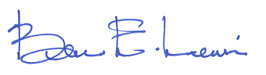
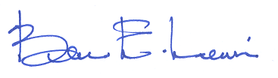
Sincerely,

Bruce E. Lewis
City Planner Supervisor – Current Planning Division
City of Jacksonville - Planning and Development Department
214 North Hogan Street, Suite 300
Jacksonville, FL 32202
(904) 255-7820
blewis@coj.net

